ROBERTSON STATE SCHOOL UNIFORM SHOP
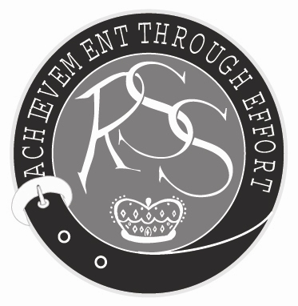
ORDER FORM
Valid August 2024
Uniform Shop Hours: Monday 2:15-3:45pm, Thursday 8:15-9:45am

 | Sizes Available | Price | Size | Quantity | Total Cost
Girls Tunic | 4-24 | $46.00
Girls Plain Blouse | 2-24 | $25.00
Girls Shorts | 2-18 | $31.50
Girls Skort | 2-18 | $31.50
Girls Formal Blouse | 4-22 | $33.50
Boys Shorts | 2-24 | $31.00
Boys Formal Shirt | 2-24 | $32.50
Sport Polo Shirt | 4-24 | $32.00
Formal Slacks | 4-20 | $42.00
Formal Sweatshirt | 4-2XL | $33.00
Sports Jacket | 6-24 | $65.00
Sports Track Pants | 6-24 | $55.00
School Hat | XS, S, M, L, XL | $37.00
Toggle |  | $2.50
Navy Socks (2 pairs) | 9-12, 13-3, 2-8, 7-11 | $12.50
White Socks (2 pairs) | 9-12, 13-3, 2-8, 7-11 | $12.50
Music Socks | 13-3, 2-7, 7-11 | $8.00
Tights | 3-5, 4-6, 7-9, 10-12, Lady’s sizes | $12.50
School Backpack |  | $57.00
Trolley Backpack | New! | $145.00
Library Bag |  | $12.00
Chair Bag |  | $16.00
Music Tote Bag |  | $17.00
Navy Headband |  | $6.50
Navy Hair Ties | 10 pack | $4.00
Navy Hair Clips | 6 pack | $4.00
Tartan Hair Ribbon | 60cm lengths | $3.00
Tartan Scrunchies |  | $4.00
Sports Socks | 2-7, | $7.00
Soccer Socks | 2-7, 7-11 | $9.50
Sports Visor | M, L | $9.50
Badge |  | $3.50
Buttons |  | $0.30

Family Name |  |  |  | Childs Name & Class
Amount Enclosed |  | $ |  | Deliver to class or Will Collect

Credit Card Number: ________ ________ ________ ________ Expiry Date: ____/____ CVV: _________
Parent Name: |  | Phone Number:

Methods of payment are EFTPOS, Cash or Credit card.

Send orders to pandc@robertsonss.eq.edu.au

ROBERTSON STATE SCHOOL UNIFORM SHOP
PRICE LIST
Valid August 2023
Uniform Shop Hours: Monday 2:15-3:45pm, Thursday 8:15-9:45am

 | Item | Price
Girls Formal
 | Tunic | $46.00
 | Plain Blouse | $25.00
 | Shorts | $31.50
 | Skort | $31.50
 | Formal Blouse | $33.50
 | Slacks | $42.00
 | Sweatshirt | $33.00
 | Tights | $12.50
Boys Formal
 | Boys Shorts | $31.00
 | Formal Shirt | $32.50
 | Slacks | $42.00
 | Sweatshirt | $33.00
Sports Uniform
 | Polo Shirt | $31.00
 | Sports Jacket | $65.00
 | Track Pants | $55.00
Hat
 | School Hat | $37.00
 | Toggle | $2.50
General Items
 | Navy Socks (2 pairs) | $12.50
 | White Socks (2 pairs) | $12.50
 | Music Socks | $8.00
Bags
 | School Backpack | $57.00
 | Library Bag | $12.00
 | Chair Bag | $16.00
 | Music Tote Bag | $17.00
 | Pencil Case | $2.50
 | Badge | $3.50
Hair Accessories
 | Navy Headband | $6.50
 | Navy Hair Ties | $4.00
 | Navy Hair Clips | $4.00
 | Tartan Hair Ribbon | $3.00
 | Tartan Scrunchies | $4.00
Sports Accessories
 | Sports Socks | $7.00
 | Soccer Socks | $9.50
 | Sports Visor | $9.50
 | Buttons | $0.30
 | Tartan Fabric | $19.25/m
 | Neck Cooler | $10.00

